CHAPTER 1

BASIC PLUMBING LAYOUT

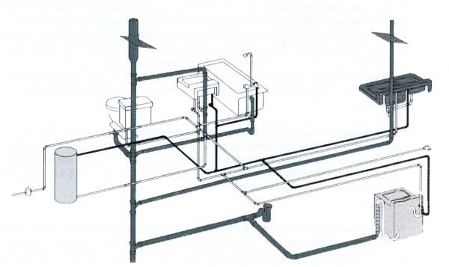

BASIC PLUMBING LAYOUT
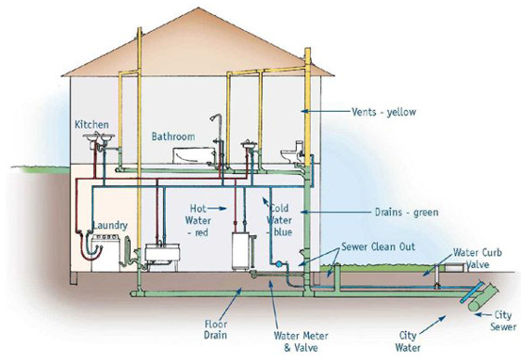
Plumbing is the system of pipes and drains installed in a building for the distribution of potable drinking water and the removal of waterborne wastes.

There are multiple plumbing systems within a building. Some of them include:
- Potable cold and hot tap water supply
- Plumbing drainage and venting
- Septic systems
- Rainwater, surface, water drainage
- Fire systems

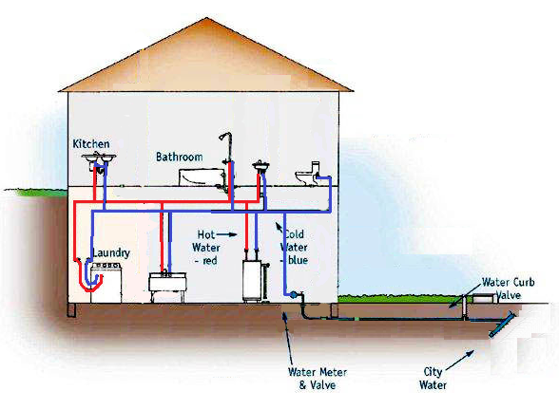
THE DISTRIBUTION SYSTEM
The supply system provides water throughout the entire structure.

The distribution system is commonly supplied by a city water supply. The supply line is commonly monitored by a water meter and will have multiple shutoff points throughout the system.

Depending on the application, the supply system is pressurized either from the city supply or by pumps.

The cold water lines will be supplied directly from the main water line. While the hot water is provided from a hot water tank or hot water heater. The hot water tank, or heater, is connected to the main water line and converts it to hot water. The how water is then separately piped throughout the building.

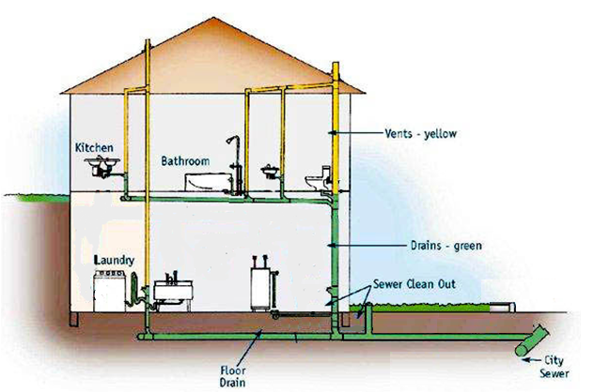
THE DRAINAGE SYSTEM
The drainage system provides a exit waste line for used water and water encapsulated particles from the structure.

The drainage system in a building is all connected and runs to a main drain line that connects to the city sewer system.

Drain lines are not under any pressure and are sloped towards the building outlet. This allows gravity to move the water away from the drains out of the building.

Drain lines also have a venting system to allow air into the lines. This helps water in the drain lines flow more efficiently.

Throughout the system are cleanouts. Cleanouts allow access points to the drain line for cleaning and maintenance of the drainage system.

