CHAPTER 8

ROOF DRAINS

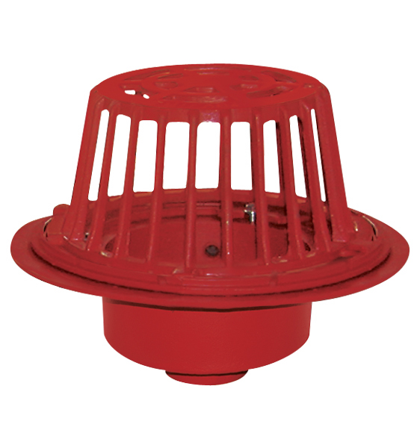

ROOF DRAINS

**Roof Drains** and accessories combine to form the upstream or entrance terminals of the roof drainage system and play a key role in the success or failure of the system. Prior to sizing and placement of drains, there are certain basic roof design factors that must be considered when selecting and specifying the proper roof drains and accessories for the job. Even though all roofs serve the same basic purpose of protecting the building and its contents from the elements, their design, composition, construction and drainage requirements do vary. Accordingly, when the specifications for the roof drains and accessories are developed, it is of vital importance that all design factors of the roof be addressed and reflected in the products specified to ensure a trouble free, successful installation. Also, compliance with the specifications is essential, for departure there from could result in a substandard roof drain installation potentially doomed to ultimate failure. Basic roof design factors for consideration with recommended drainage products follow.

* + - 1. Typical Roof Drain Assemblies
         1. Sump Receivers

The roof drain body needs to have proper support. To do this the opening in the deck of the roof needs to be just large enough to accept the sump of the roof drain body. This will not be an issue if the drain body is installed in a poured concrete deck with the drain in place. It is always recommended that the minimum opening be used in the deck for the drain. If the size of the opening cannot be kept to the recommended minimum. Then a sump receiver, also called a drain receiver, should be specified with the drain to compensate for deck openings.

A piece of sheet metal that has a center recess that the drain body sits in allowing the top of body to remain flush with the decking.

* + - * 1. Underdeck Clamps

The drain body must be secured to the roof decking. The most effective and positive means available is the use of an underdeck clamp. The underdeck clamp is attached to the drain body with threaded rod, nuts and washers. The flange of the body, or sump receiver, and the underdeck clamp are used together to sandwich the drain to the roof deck. The roof drain then becomes an integral component of the roof decking.

* + - * 1. Adjustable Extensions

An adjustable extension is used to extend the roof drain off the decking. This is normally used when installation and roofing membrane is applied on top of the decking. Majority of installations cannot be used as a solid surface for mounting the drain body. The adjustable extension uses two underdeck clamps, threaded rods, nuts and washers. The two underdeck clamps are used to sandwich the roof deck allowing the drain body to extend above the roof deck.

* + - * 1. Adjustable Ballast Guard

Used on roofing applications where the roofing membrane is under the insulation. The main benefit to this type of roof is because the insulation will protect the membrane from damaging weather conditions. The membrane is placed directly on the roof decking. The insulation with specially designed drainage grooves is placed on top of the membrane. Then a layer of aggregate gravel is placed on top of the insulation to secure the insulation while allowing efficient drainage away from the surface. The ballast guard allows water to enter the drain below the roof level and keeps the gravel from entering the drain.

* + - * 1. Water Dam

Some roofs are designed to contain a certain amount of water at all times. This is normally done to control the amount of water that enters a drain system, minimizing the possibility flooding the drain system. Water will not enter the drain until the water level is above the water dam. Some models have an option for an internal water dam where the water dam is located inside of the dome strainer. And an external water dam, where the water dam is located on the outside of the dome strainer.

* + - * 1. Overflow Drainage

Most applications need an overflow system installed in the event of blockage or an overflow of the main storm drain system. The overflow system is usually a completely separate drainage system. This can be done by installing separate drains with water dams. This would allow the overflow system to only work when the water level on the roof reaches a certain level. The other option is to install a combination drain that has the main roof drain and overflow drain in one unit.

See R1150, R1270 and R1200-SO.

* + - * 1. Expansion and Contraction Joints

Expansion and contraction, primarily caused by alternating hot and cold environmental conditions, are of particular concern with roof decks and topping materials. Because of this roofs are designed to allow a certain amount of expansion and contraction. Therefore the drain system must also be allowed to expand and contract with the roofing and still maintain a water tight seal. An expansion joint is used to allow movement in the pipe while maintaining a water tight seal.

R1900 Series.

* + - * 1. Scupper Drains

Scupper drains are designed for a Parapet style roof. A parapet style roof has a wall around the perimeter of the roof. Parapets were originally used to defend buildings from military attack, but today they are primarily used to prevent the spread of fires. Scupper drains are installed in the corner of the roofing and the parapet wall.

R1300, R1310, R1320 and R1330 Series.

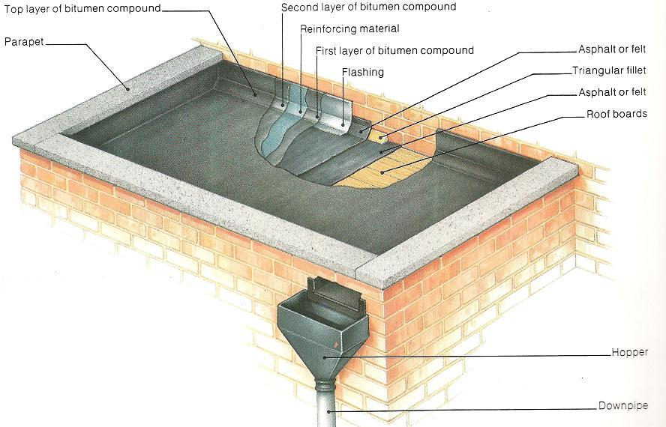

Parapet Roof

* + - * 1. Accuflow Weir

Weir is designed to control the amount of flow through the drain. The weir is coned shape and is installed on top of the membrane clamp under the roof drain dome. It has 1, 2 or 3 slots, depending on the required flow. The slots are designed to allow a certain amount of flow per inch of water on the roof. This allows the control of rain water that enter the drainage system to prevent it from overflowing. Because of this the roof needs to be designed to retain a certain amount of water without collapsing.

Weirs can be modified for custom flow rates.

R1100-F and R1200-F Series.

* + - * 1. Promenade Roof Drains

Promenade roof drains are used on roofs that will have pedestrian traffic. The drain is equipped with strainer top assembly.

R1100-PR, R1100-PJ and R1200-PR Series.

* + - * 1. Balcony Drains

Balcony drains are a smaller size drain designed for drainage of smaller areas. The drains include a smaller dome and a membrane clamping collar. The balcony drain bodies are available in bottom, 45 degree and 90 degree outlets. The strainer has a 4” NPSM which is the same as the F1000 Series strainers.

R1400, R1410 and R1420 Series.

* + - 1. 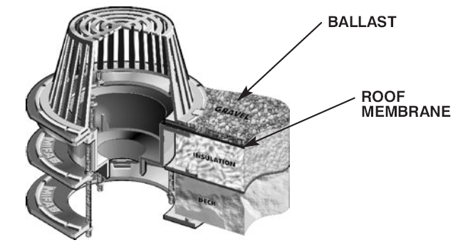Typical Roof Drain Installations

**R1200-EU**

Roof drain with adjustable deck flange for varying thicknesses of insulation.

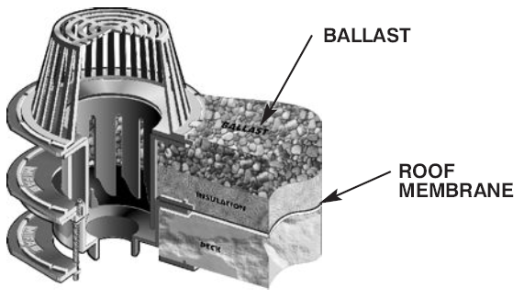

**R1200-HC**

Roof drain with adjustable ballast and insulation guard.

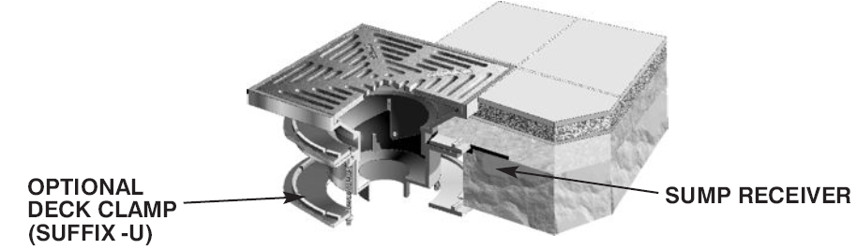

**R1200-P-BU**

Promenade roof drain with sump receiver and adjustable collar.

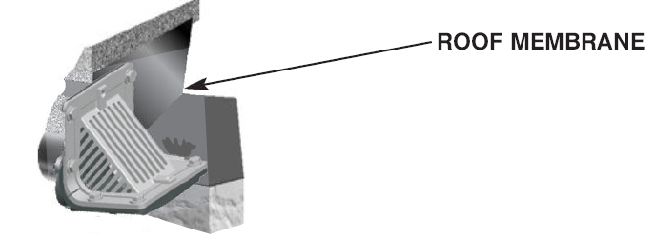

**R1300**

Scupper drain with flashing clamp. For installations at the base of parapets.

* + - 1. Roof Drain Sizing
         1. Warehouse is being built in Cleveland, OH. The building is 200’ x 400’ with a flat roof with no appreciable vertical surface.

Calculate the total area of the roof

200’ x 400’ = 80,000 sq. ft.

Determine the number of drains that are required.

Typical sizing rule is 1 drain per 10,000 sq. ft. = 8 drains

Find rainfall rate, one hour storm duration and 100 year return period, for Cleveland, OH. (Page 114)

Cleveland, OH = 2.8 inches/hour

Convert rainfall from inches/hour to gallons/minute (GPM)

.0104 x inches/hour x roof total area=

.0104 x 2.8 x 80,000 = 2330GPM

Calculate the expected flow for each drain.

GPM / number of drains = 2330 / 8 = 292GPM

Determine vertical leader size from Chart A on page 119.

Determine what size is capable of 292GPM = 6”vertical leader

Determine the horizontal leader size, combined flow of vertical leaders.

Need to know the roof slope and determine from Chart B on page 119.

* + - 1. Roof Drain Model Numbers
         1. R1100 Series

Use A1 body and A1 components.

Typically used for smaller roof areas.

* + - * 1. R1200 Series

Use A2 body and A2 components

Our most common roof drain Series

R1200-SO uses a fabricated body with A2 components.

* + - * 1. R1220 Series

Use A5 body and A5 components.

Has a smaller capacity than the R1200 Series.

* + - * 1. R1250 Series

Extra deep sump, uses the A3T-PB body.

Transition body assembly that allows all the connection types and sizes that are offered with the A1 body.

Assembly will only have the flow area of a 4” pipe due to the transition layout.

* + - * 1. R1260 Series

Extra large drains that available in 10” No Hub, 10” inside caulk and 12” No Hub.

Uses the A7 body, membrane clamp, and underdeck clamp. It also uses the A2 style domes.

* + - * 1. Siphonix Roof Drains

Siphonix Roof Drain system is designed to utilize more are in the drain pipes for flow. This allows for smaller pipe systems which reduce cost and save space.

Use A2 body and components with a Siphonic Air Baffle (A2-SR) installed.

Any technical inquires should be sent to Mike Richmond.

* + - * 1. Scupper Drains

R1300T, R1310, R1320T and R1330 Series

R1300T and R1320T Series are received as the complete assembly in cast iron.

Nickel bronze top assemblies (R1300-TA-1, R1306-TA-1, R1320-TA-1 and R1326-TA-1) are available. They come with the grate and two clamps and are installed on the body when needed.

The R1310 and R1330 Series have the R1300-POx-50 installed on a R1300 or R1320 to create the 45 degree outlet.

* + - * 1. Downspout Boots

R1510, R1520 and R1530 Series

A transition piece from the vertical downspout to the underground drainage system.

* + - * 1. Parapet Scupper Sleeve

R1640 Series

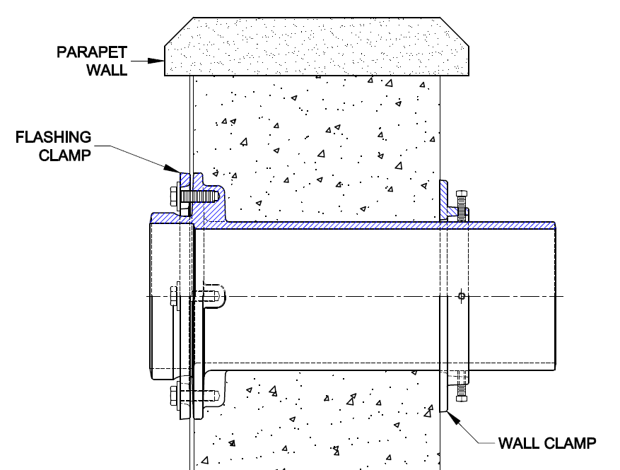[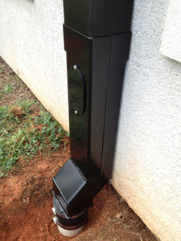](http://www.google.com/url?sa=i&rct=j&q=downspout+boot&source=images&cd=&cad=rja&docid=PR9mKG2gO30M6M&tbnid=vF3MppEtWgu63M:&ved=0CAUQjRw&url=http%3A%2F%2Fwww.piedmontpipe.com%2Foffset-vertical-shoe%2F&ei=9S0ZUYjZDIuFqQGV94HwDA&psig=AFQjCNGqnIUX2qW1Cnuyi27goQM3b6Q4Kw&ust=1360690680974201)Allows penetration through the Parapet roof wall.

Downspout Boot Parapet Scupper Sleeve

* + - * 1. Downspout Nozzles

R1940 and R1960 Series

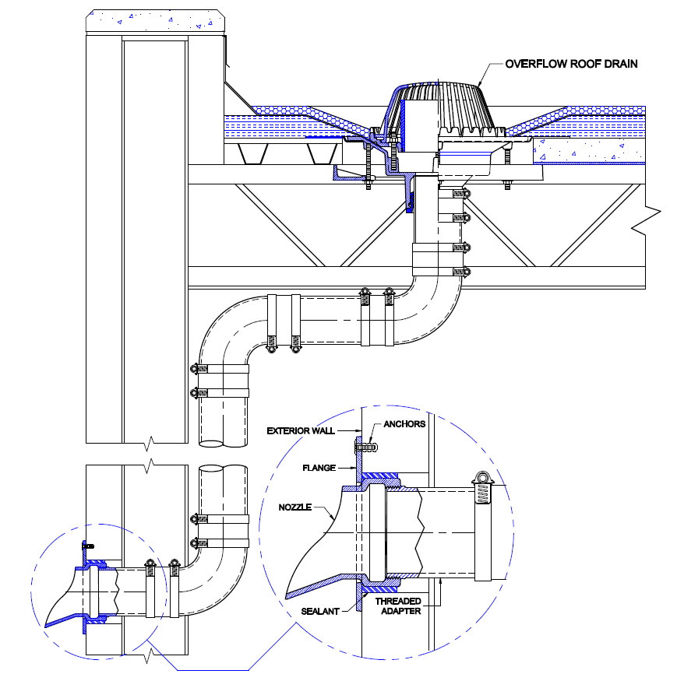Creates an outlet point for a drain system that ends above ground level.